How to use Github Ubuntu

Hi now i will show you how to work with commands in terminal. I will show you commands for GitHub. With this lesson you will learn how to clone your repository, setup your user name, initialize your git on your computer (you must do that if you didn’t initialize it never before), add files --> push files, commit. I will add screen shots. In future i can make video tutorial. GitHub is a web-based hosting service for software development projects that use the Git revision control system.

Ubuntu:
First you need to configurate your user name and email by using the commands:
git config –global user.name “username”
git config –global user.email “Email”
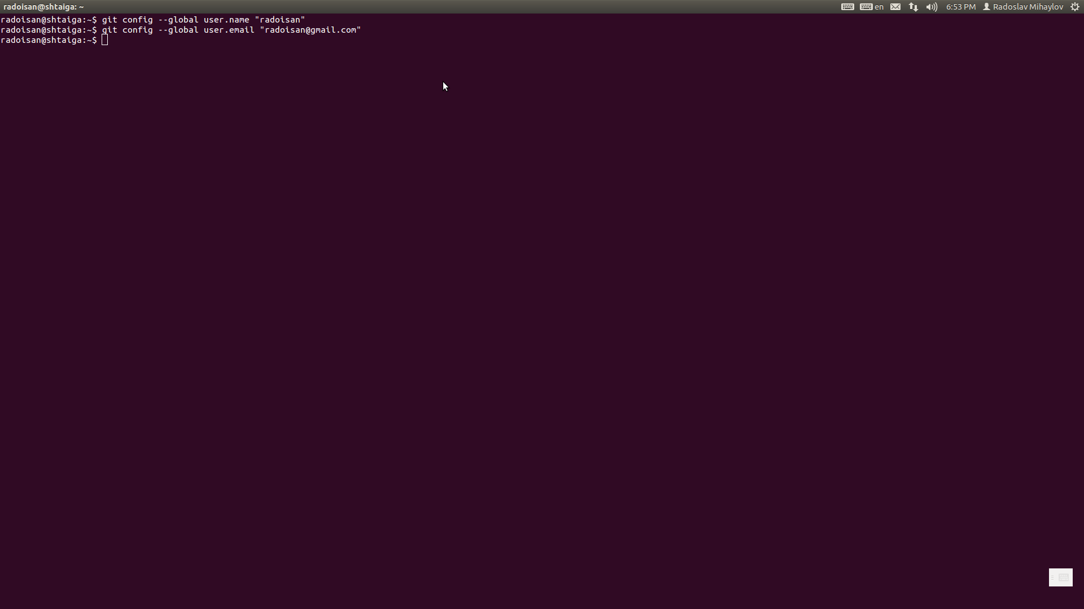

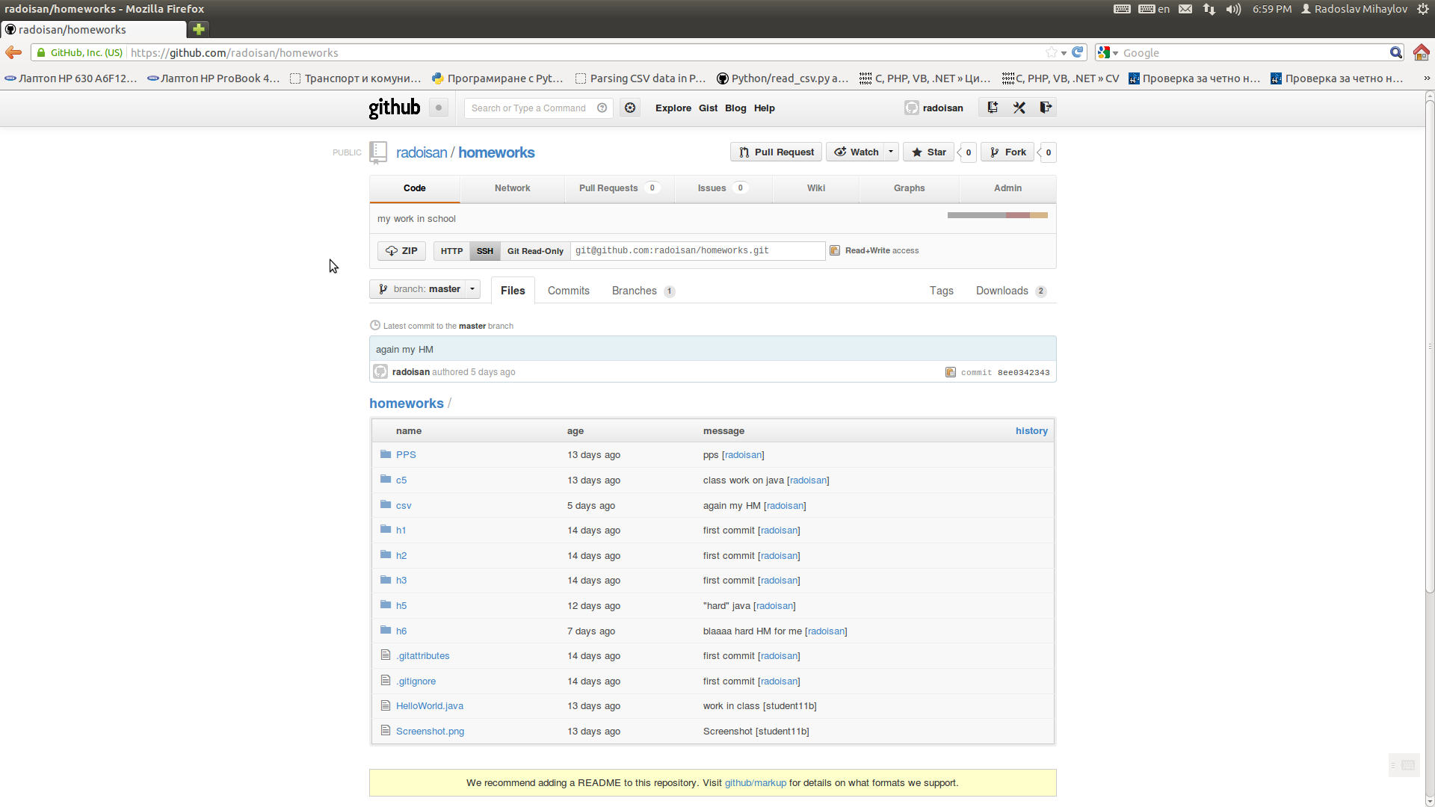
Next you need to initialize your git on your computer (this step is only necessary if you didn’t initialize it never before).
This is made by using using the HTTP link and the following commands:
git init
git clone “repositoryURL”

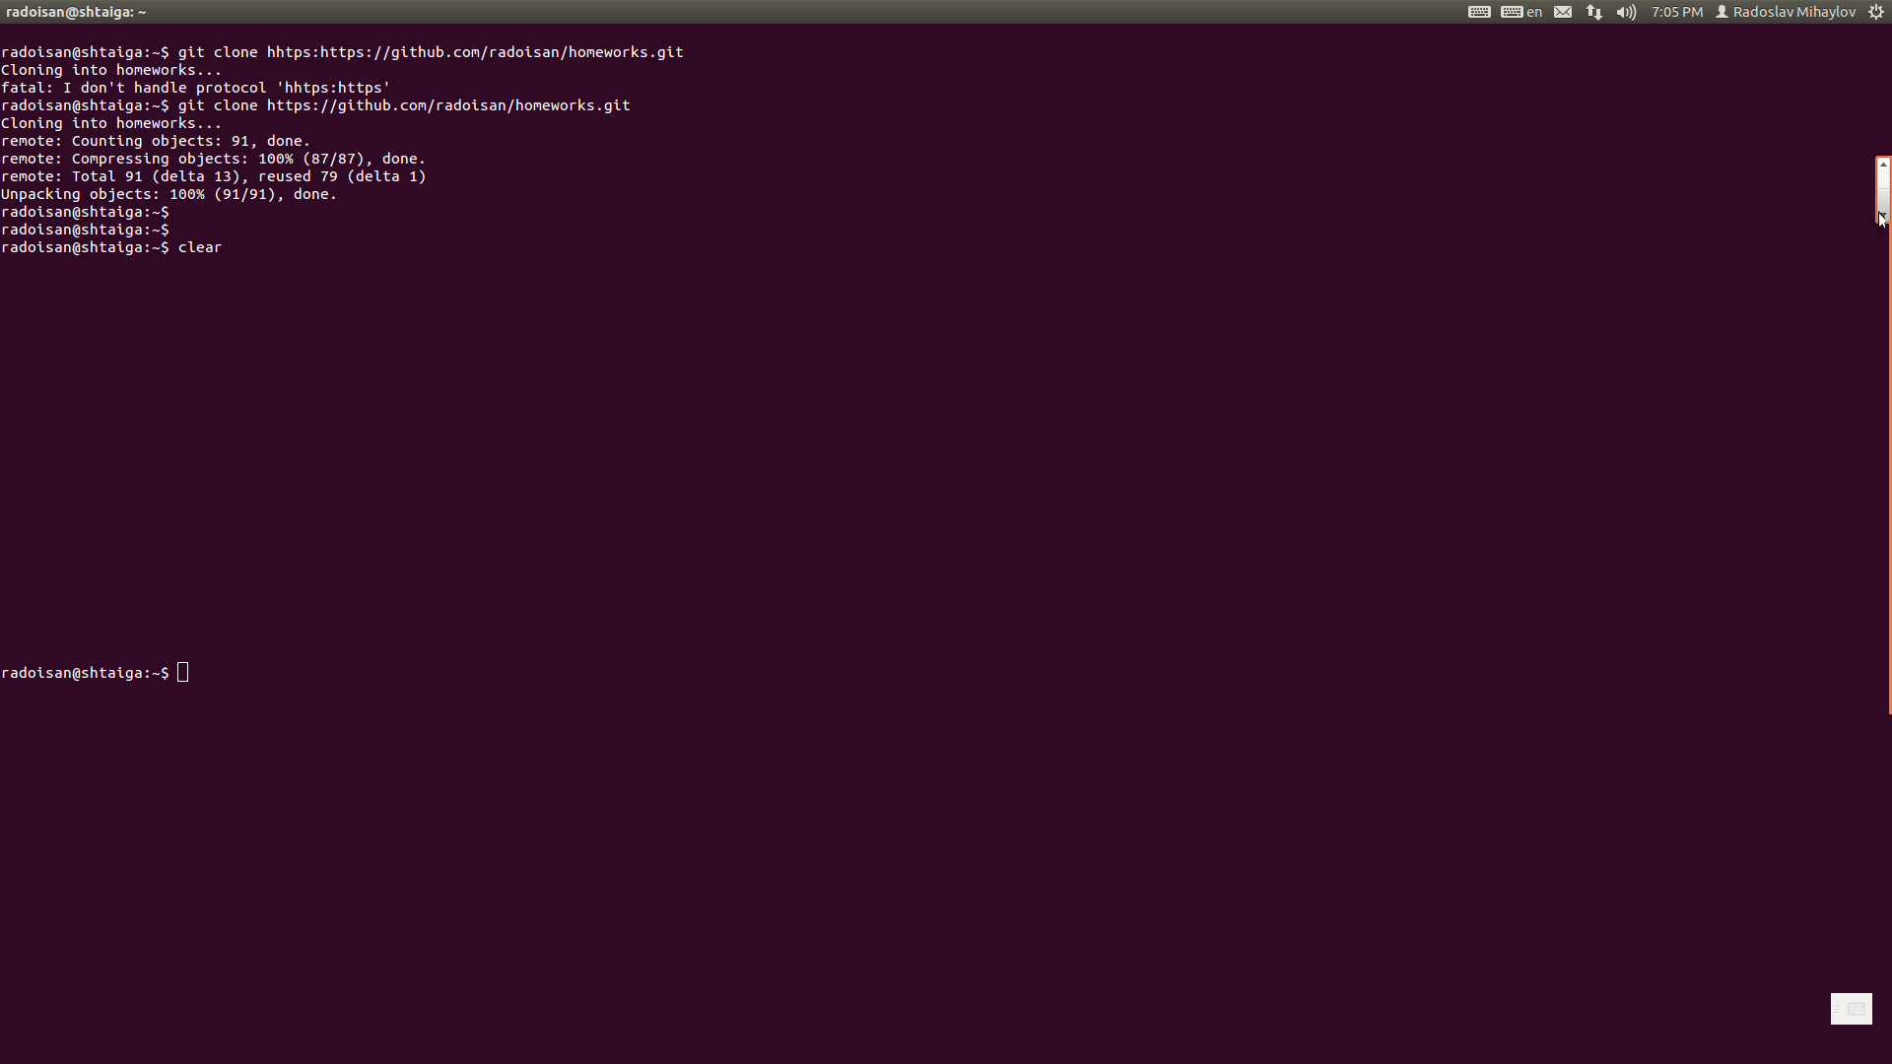
After that you need to enter your cloned repository and copy your files inside or just start working there.

Then you will be able to add some file to your repository.
To add the file to your repository you need to use commands:
git add . (where the dot is used to add all new files to the commit)
git commit -m “theReason” (you need to use -m “text”, where text is the reason for your commit)
git push
To add the file to your repository you need the command add followed by the name of the file, you want to add. You can also add whole folders. In ma case I will add folder “h7”. You need go in dolder where is your repo by using command cd.
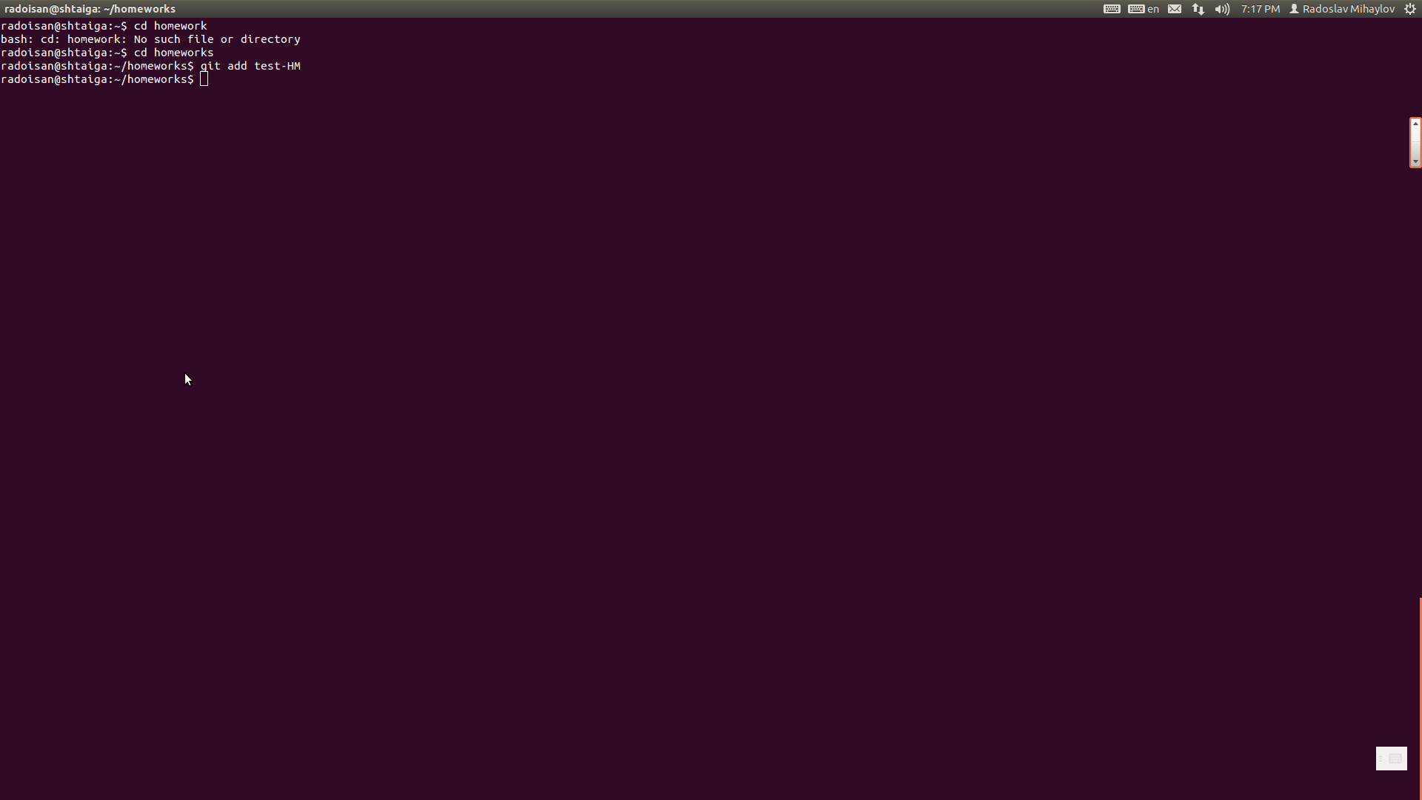
Next, you need a commit message, to know what are you adding.

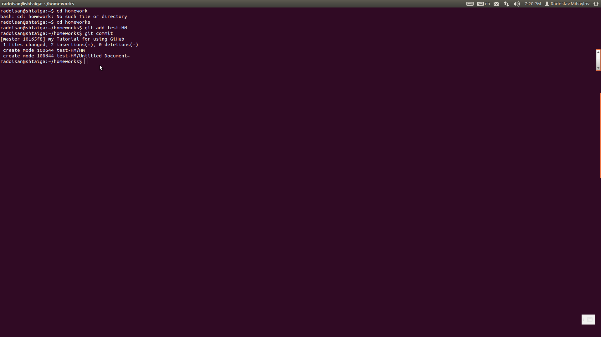
This command will open a dialog box to write some message.
Then, you only need to push the file.
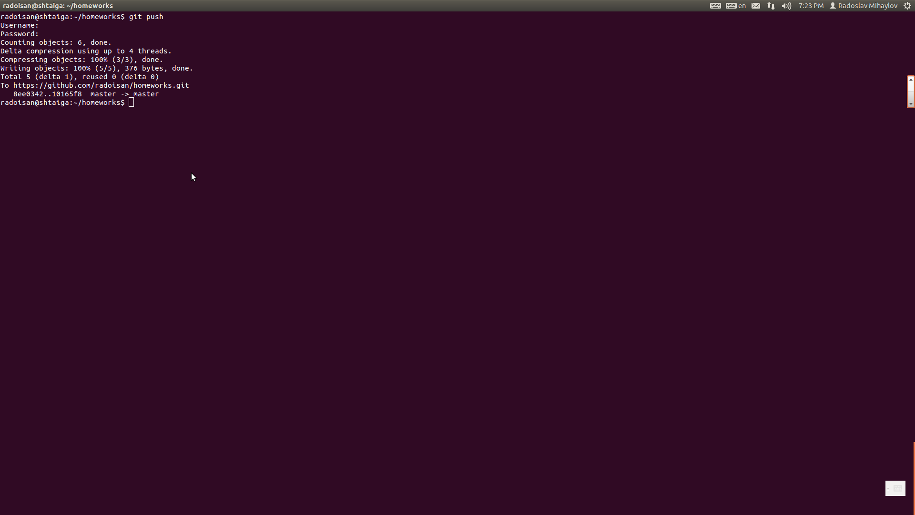
Then you need to type you username and password for your github account and you are ready.

To pull the files is like to update your files on your computer with these on the storage. In my case:
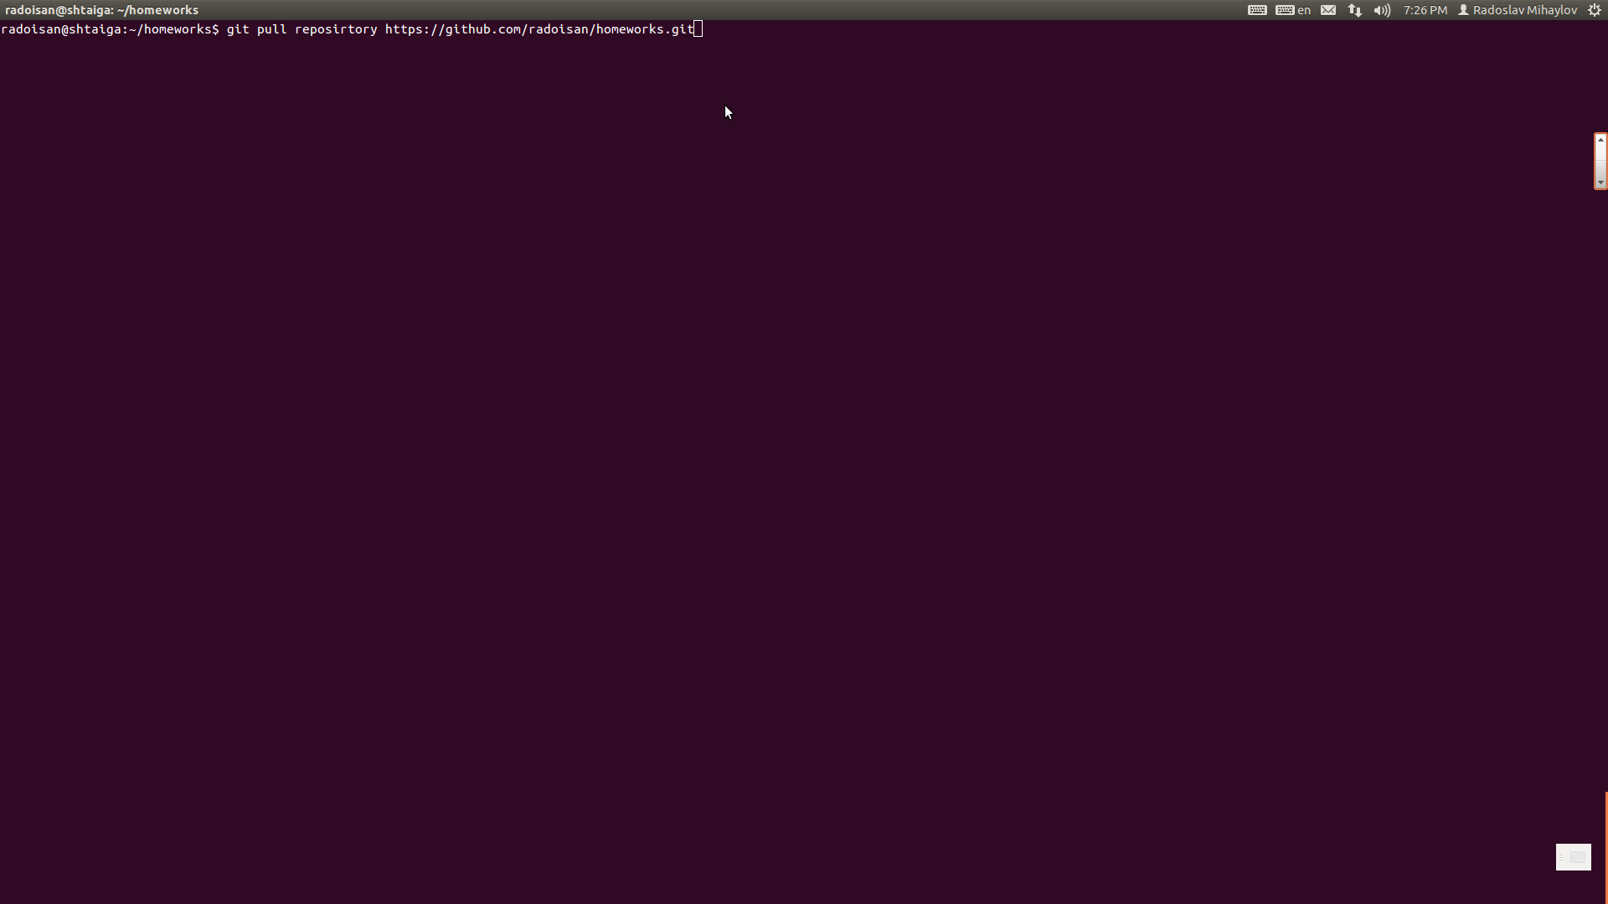
Update command downloads all the files, in your repo, that you don’t have, but don’t change the ones, you have.
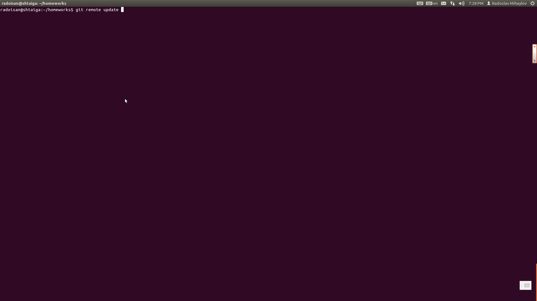
So that was about it. Always you can download the GUI program for Windows and to live happily ever after. I use GUI when I am in Windows it's easy :)))

